**ROLL NO. 96**

**NAME:-Prajwal Santosh Mankar**

**Practical No:-2**

**Practical Name:-Clone the repository at** <https://github.com/KBCNMU>.

_______________________________________________________________________­­­­

pmank@LAPTOP-046D1TRN MINGW64 ~

$ git --version

git version 2.40.0.windows.1

pmank@LAPTOP-046D1TRN MINGW64 ~

$ git clone https://github.com/pmankar02/KBCNMU.git

Cloning into 'KBCNMU'...

warning: You appear to have cloned an empty repository.

pmank@LAPTOP-046D1TRN MINGW64 ~

$ git clone https://github.com/pmankar02/KBCNMU.git

Cloning into 'KBCNMU'...

remote: Enumerating objects: 3, done.

remote: Counting objects: 100% (3/3), done.

remote: Total 3 (delta 0), reused 0 (delta 0), pack-reused 0

Receiving objects: 100% (3/3), done.

pmank@LAPTOP-046D1TRN MINGW64 ~

$ git --help

usage: git [-v | --version] [-h | --help] [-C <path>] [-c <name>=<value>]

[--exec-path[=<path>]] [--html-path] [--man-path] [--info-path]

[-p | --paginate | -P | --no-pager] [--no-replace-objects] [--bare]

[--git-dir=<path>] [--work-tree=<path>] [--namespace=<name>]

[--config-env=<name>=<envvar>] <command> [<args>]

These are common Git commands used in various situations:

start a working area (see also: git help tutorial)

clone Clone a repository into a new directory

init Create an empty Git repository or reinitialize an existing one

work on the current change (see also: git help everyday)

add Add file contents to the index

mv Move or rename a file, a directory, or a symlink

restore Restore working tree files

rm Remove files from the working tree and from the index

examine the history and state (see also: git help revisions)

bisect Use binary search to find the commit that introduced a bug

diff Show changes between commits, commit and working tree, etc

grep Print lines matching a pattern

log Show commit logs

show Show various types of objects

status Show the working tree status

grow, mark and tweak your common history

branch List, create, or delete branches

commit Record changes to the repository

merge Join two or more development histories together

rebase Reapply commits on top of another base tip

reset Reset current HEAD to the specified state

switch Switch branches

tag Create, list, delete or verify a tag object signed with GPG

collaborate (see also: git help workflows)

fetch Download objects and refs from another repository

pull Fetch from and integrate with another repository or a local branch

push Update remote refs along with associated objects

'git help -a' and 'git help -g' list available subcommands and some

concept guides. See 'git help <command>' or 'git help <concept>'

to read about a specific subcommand or concept.

See 'git help git' for an overview of the system.

**OUTPUT :**

**Repository on GitHub :**

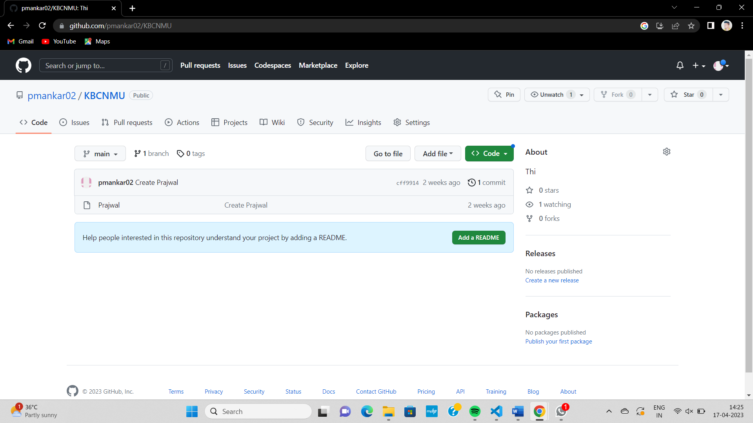

**Repository on Local pc :**

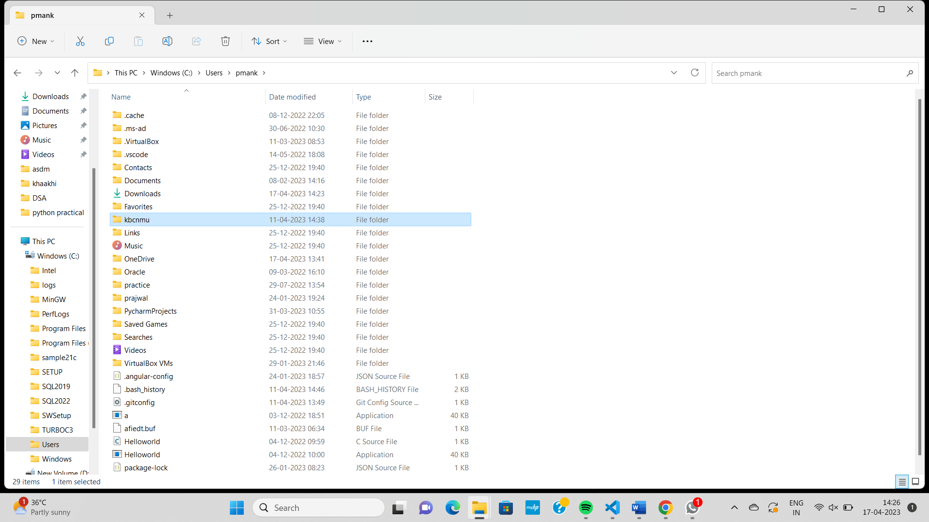

**Roll No:-96**

**Name:- Prajwal Santosh Mankar**

**Practical No:-3**

**Practical Name :-use git add to add that file to the repository use git command to commit**

**your change**

**______________________________________________________________________________**

pmank@LAPTOP-046D1TRN MINGW64 ~

$ git clone https://github.com/pmankar02/KBCNMU.git

fatal: destination path 'KBCNMU' already exists and is not an empty directory.

pmank@LAPTOP-046D1TRN MINGW64 ~

$ cd KBCNMU

pmank@LAPTOP-046D1TRN MINGW64 ~/KBCNMU (main)

$ git init KBCNMU

Initialized empty Git repository in C:/Users/pmank/KBCNMU/KBCNMU/.git/

pmank@LAPTOP-046D1TRN MINGW64 ~/KBCNMU (main)

$ touch file.txt

pmank@LAPTOP-046D1TRN MINGW64 ~/KBCNMU (main)

$ git add file.txt

pmank@LAPTOP-046D1TRN MINGW64 ~/KBCNMU (main)

$ git commit -m "first commit"

Author identity unknown

*** Please tell me who you are.

Run

git config --global user.email "you@example.com"

git config --global user.name "Your Name"

to set your account's default identity.

Omit --global to set the identity only in this repository.

fatal: unable to auto-detect email address (got 'pmank@LAPTOP-046D1TRN.(none)')

pmank@LAPTOP-046D1TRN MINGW64 ~/KBCNMU (main)

$ ^C

pmank@LAPTOP-046D1TRN MINGW64 ~/KBCNMU (main)

$ ^[[200~ git config --global user.email "you@example.com"

bash: $'\E[200~': command not found

pmank@LAPTOP-046D1TRN MINGW64 ~/KBCNMU (main)

$ git config --global user.email "pmankar02@gmail.com"

git: 'config' is not a git command. See 'git --help'.

The most similar command is

config

pmank@LAPTOP-046D1TRN MINGW64 ~/KBCNMU (main)

$ git config --global user.email "pmankar02@gmail.com"

pmank@LAPTOP-046D1TRN MINGW64 ~/KBCNMU (main)

$ git config --global user.name "pmankar02"

pmank@LAPTOP-046D1TRN MINGW64 ~/KBCNMU (main)

$ git commit -m "first commit"

[main c51b1c3] first commit

1 file changed, 0 insertions(+), 0 deletions(-)

create mode 100644 file.txt

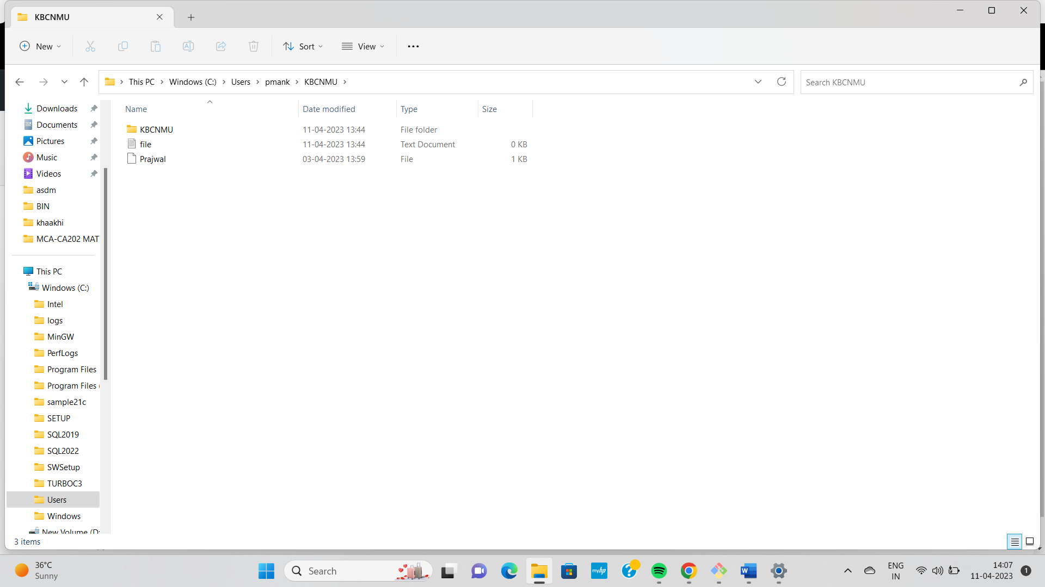

NAME:-Prajwal Santosh Mankar

ROLL NO:- 96

PRACTICAL NO:-4

PRACTICAL NAME:- use git push to send your change to the primary repository.Look

Online to see if you changes has been pushed.

______________________________________________________________________________________

pmank@LAPTOP-046D1TRN MINGW64 ~

$ git clone https://github.com/pmankar02/mca-.git

Cloning into 'mca-'...

remote: Enumerating objects: 3, done.

remote: Counting objects: 100% (3/3), done.

remote: Total 3 (delta 0), reused 0 (delta 0), pack-reused 0

Receiving objects: 100% (3/3), done.

pmank@LAPTOP-046D1TRN MINGW64 ~

$ cd mca

bash: cd: mca: No such file or directory

pmank@LAPTOP-046D1TRN MINGW64 ~

$ cd mca-

pmank@LAPTOP-046D1TRN MINGW64 ~/mca- (main)

$ touch mca_2.txt

pmank@LAPTOP-046D1TRN MINGW64 ~/mca- (main)

$ git add mca_2.txt

pmank@LAPTOP-046D1TRN MINGW64 ~/mca- (main)

$ git status

On branch main

Your branch is up to date with 'origin/main'.

Changes to be committed:

(use "git restore --staged <file>..." to unstage)

new file: mca_2.txt

pmank@LAPTOP-046D1TRN MINGW64 ~/mca- (main)

$ git commit -m "first file"

[main 08b285b] first file

1 file changed, 0 insertions(+), 0 deletions(-)

create mode 100644 mca_2.txt

pmank@LAPTOP-046D1TRN MINGW64 ~/mca- (main)

$ git push -u origin main

Enumerating objects: 4, done.

Counting objects: 100% (4/4), done.

Delta compression using up to 8 threads

Compressing objects: 100% (2/2), done.

Writing objects: 100% (3/3), 270 bytes | 270.00 KiB/s, done.

Total 3 (delta 0), reused 0 (delta 0), pack-reused 0

To https://github.com/pmankar02/mca-.git

653b65c..08b285b main -> main

branch 'main' set up to track 'origin/main'.

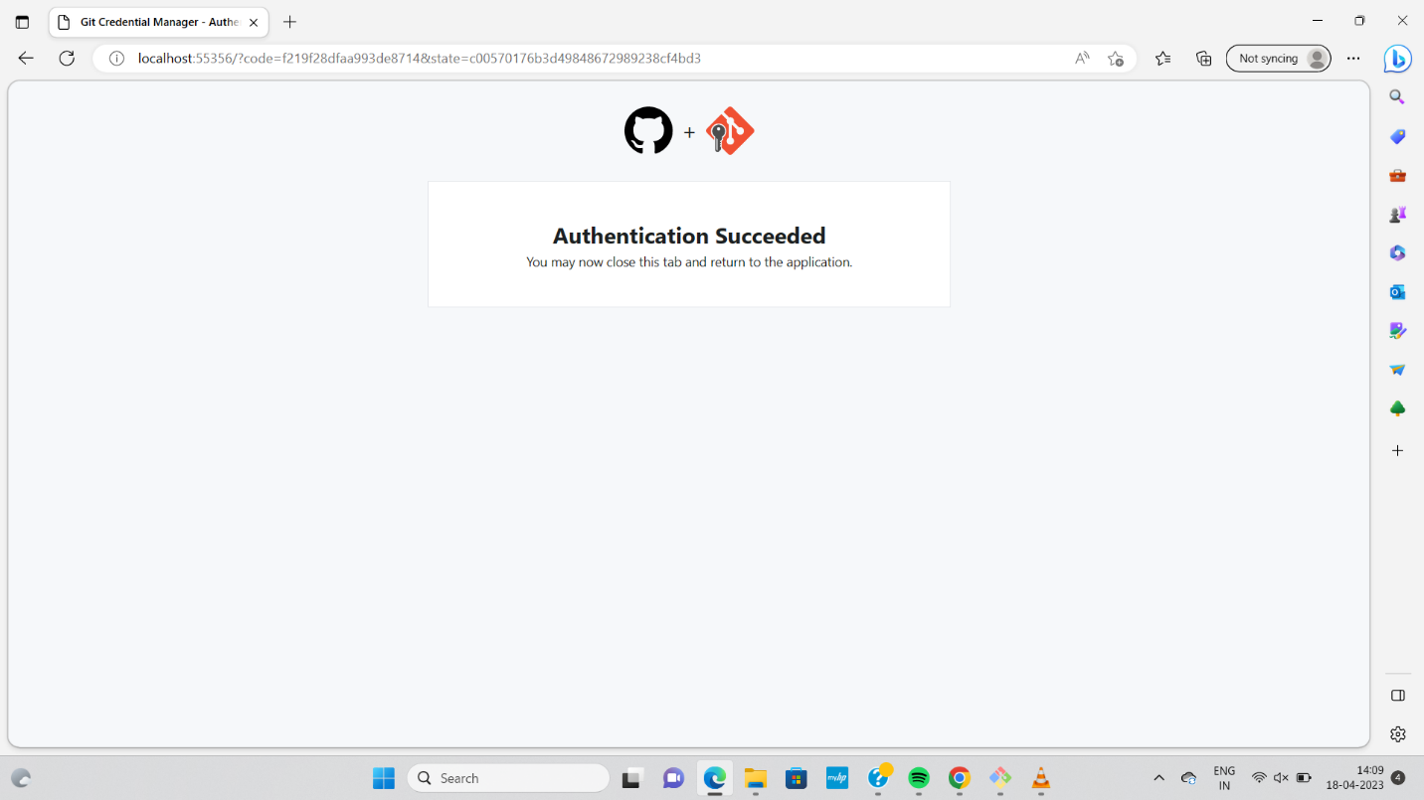

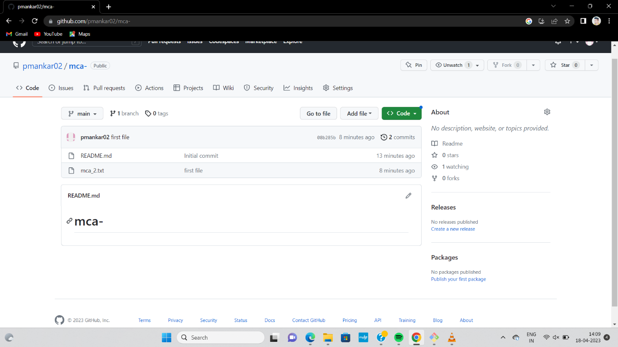

NAME:-Prajwal Santosh Mankar

ROLL NO:- 96

PRACTICAL NO:-5

PRACTICAL NAME:- use git push to send your change to the primary repository.Look

Online to see if you changes has been pushed.

pmank@LAPTOP-046D1TRN MINGW64 ~

$ cd mca

bash: cd: mca: No such file or directory

pmank@LAPTOP-046D1TRN MINGW64 ~

$ cd mca-

pmank@LAPTOP-046D1TRN MINGW64 ~/mca- (main)

$ git init mca-

Initialized empty Git repository in C:/Users/pmank/mca-/mca-/.git/

pmank@LAPTOP-046D1TRN MINGW64 ~/mca- (main)

$ git pull https://github.com/pmankar02/KBCNMU.git

remote: Enumerating objects: 3, done.

remote: Counting objects: 100% (3/3), done.

remote: Total 3 (delta 0), reused 0 (delta 0), pack-reused 0

Unpacking objects: 100% (3/3), 610 bytes | 67.00 KiB/s, done.

From https://github.com/pmankar02/KBCNMU

* branch HEAD -> FETCH_HEAD

fatal: refusing to merge unrelated histories

pmank@LAPTOP-046D1TRN MINGW64 ~/mca- (main)

$ git pull https://github.com/pmankar02/mca-.git

remote: Enumerating objects: 4, done.

remote: Counting objects: 100% (4/4), done.

remote: Compressing objects: 100% (3/3), done.

remote: Total 3 (delta 0), reused 0 (delta 0), pack-reused 0

Unpacking objects: 100% (3/3), 288.83 KiB | 111.00 KiB/s, done.

From https://github.com/pmankar02/mca-

* branch HEAD -> FETCH_HEAD

Updating 97ffef0..c1d977e

Fast-forward

asdm 4.docx | Bin 0 -> 314282 bytes

1 file changed, 0 insertions(+), 0 deletions(-)

create mode 100644 asdm 4.docx

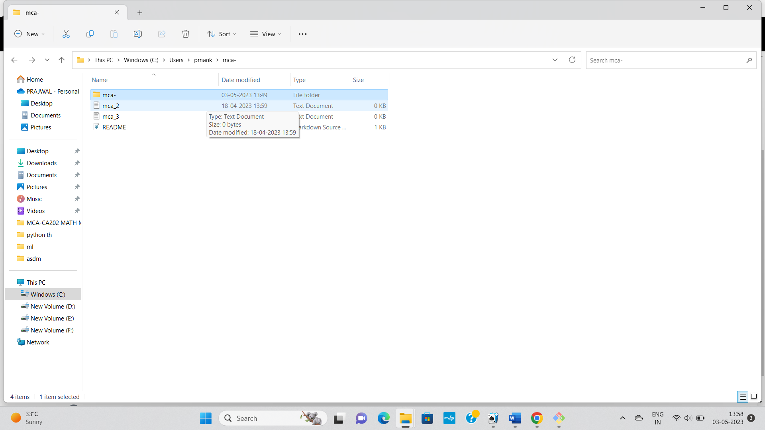

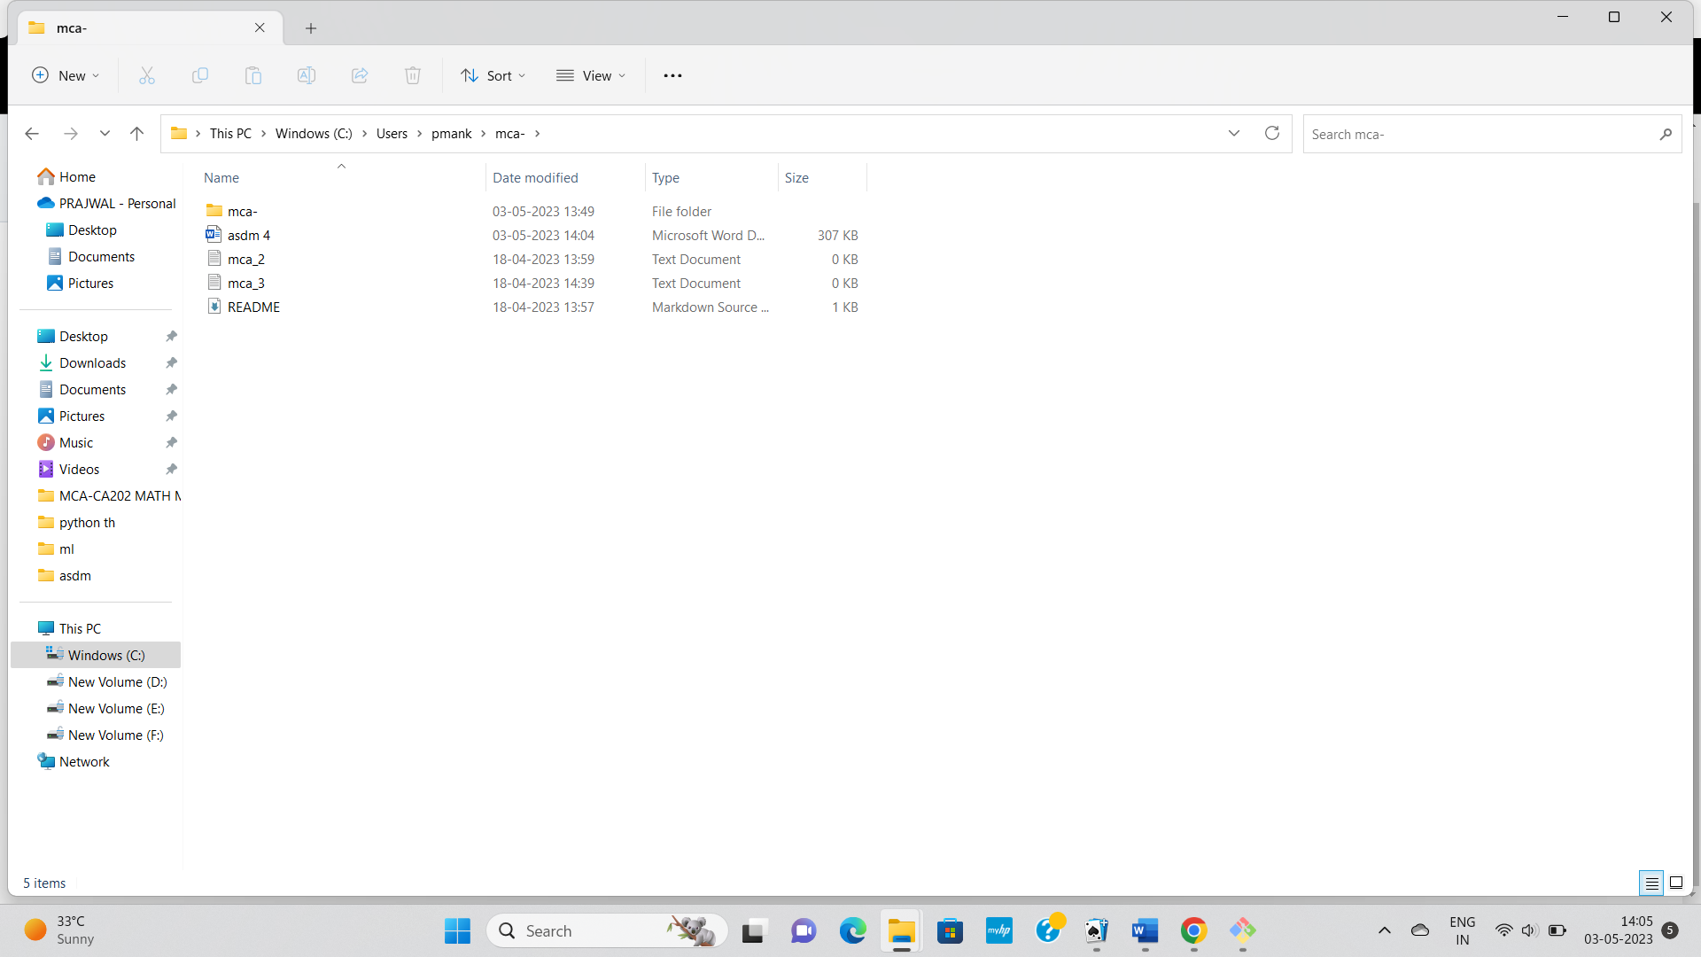

Name:- Prajwal Santosh Mankar

Roll no:- 96

Practical no:-6

Practical Name:-Use git log or git less to see a list of changes to the repository

__________________________________________________________________________________

Admin@DESKTOP-EAH8S6B MINGW64 ~

$ cd KBCNMU

Admin@DESKTOP-EAH8S6B MINGW64 ~/KBCNMU (main)

$ git log

commit c05d02180a0925682706c0ea74d52a9688d9e088 (HEAD -> main)

Merge: b04e4f2 0331eda

Author: unknown <malirina231@gmail.com>

Date: Sat May 6 21:28:30 2023 +0530

Merge https://github.com/Rinamali14/KBCNMU

commit 0331edac97f1017a61516aa8b0d27e0637603a00

Author: Rinamali14 <129167705+Rinamali14@users.noreply.github.com>

Date: Sat May 6 21:24:08 2023 +0530

Add files via upload

commit b04e4f2e3a0a54059df93ca3020b2dd2f6c5ee55

Author: unknown <malirina231@gmail.com>

Date: Fri May 5 17:16:14 2023 +0530

Hellow

commit 698aaad201967ea29477681db77d679e29c9c9a3 (origin/main, origin/HEAD)

Author: Rinamali14 <129167705+Rinamali14@users.noreply.github.com>

Date: Fri May 5 16:21:20 2023 +0530

Initial commit

Admin@DESKTOP-EAH8S6B MINGW64 ~/KBCNMU (main)

$ git log --oneline

c05d021 (HEAD -> main) Merge https://github.com/Rinamali14/KBCNMU

0331eda Add files via upload

b04e4f2 Hellow

698aaad (origin/main, origin/HEAD) Initial commit

Admin@DESKTOP-EAH8S6B MINGW64 ~/KBCNMU (main)

$ git log --stat

commit c05d02180a0925682706c0ea74d52a9688d9e088 (HEAD -> main)

Merge: b04e4f2 0331eda

Author: unknown <malirina231@gmail.com>

Date: Sat May 6 21:28:30 2023 +0530

Merge https://github.com/Rinamali14/KBCNMU

commit 0331edac97f1017a61516aa8b0d27e0637603a00

Author: Rinamali14 <129167705+Rinamali14@users.noreply.github.com>

Date: Sat May 6 21:24:08 2023 +0530

Add files via upload

Assignment 1 (2).docx | Bin 0 -> 13434 bytes

1 file changed, 0 insertions(+), 0 deletions(-)

commit b04e4f2e3a0a54059df93ca3020b2dd2f6c5ee55

Author: unknown <malirina231@gmail.com>

Date: Fri May 5 17:16:14 2023 +0530

Hellow

Rina.txt | 0

1 file changed, 0 insertions(+), 0 deletions(-)

commit 698aaad201967ea29477681db77d679e29c9c9a3 (origin/main, origin/HEAD)

Author: Rinamali14 <129167705+Rinamali14@users.noreply.github.com>

Date: Fri May 5 16:21:20 2023 +0530

Initial commit

README.md | 2 ++

1 file changed, 2 insertions(+)

Admin@DESKTOP-EAH8S6B MINGW64 ~/KBCNMU (main)

$ git log --patch

commit c05d02180a0925682706c0ea74d52a9688d9e088 (HEAD -> main)

Merge: b04e4f2 0331eda

Author: unknown <malirina231@gmail.com>

Date: Sat May 6 21:28:30 2023 +0530

Merge https://github.com/Rinamali14/KBCNMU

commit 0331edac97f1017a61516aa8b0d27e0637603a00

Author: Rinamali14 <129167705+Rinamali14@users.noreply.github.com>

Date: Sat May 6 21:24:08 2023 +0530

Add files via upload

**diff --git a/Assignment 1 (2).docx b/Assignment 1 (2).docx**

**new file mode 100644**

**index 0000000..0262bd9**

**--- /dev/null**

**+++ b/Assignment 1 (2).docx**

@@ -0,0 +1,20 @@

+Assignment 1

+#1.slice

+s = ' hello '

+s = s[3:8] # no crash if s[3:20]

+print(s)

+Output:

+hello

+

+#2. strip()

+s = ' hello '.strip()

+print(s)

+Output:

+Hello

+#31. zfill()

+s = '42'.zfill(5)

+print(s)

+s = '-42'.zfill(5)

+Print(s)

+

+

commit b04e4f2e3a0a54059df93ca3020b2dd2f6c5ee55

Author: unknown <malirina231@gmail.com>

Date: Fri May 5 17:16:14 2023 +0530

Hellow

**diff --git a/Rina.txt b/Rina.txt**

**new file mode 100644**

**index 0000000..e69de29**

commit 698aaad201967ea29477681db77d679e29c9c9a3 (origin/main, origin/HEAD)

Author: Rinamali14 <129167705+Rinamali14@users.noreply.github.com>

Date: Fri May 5 16:21:20 2023 +0530

Initial commit

**diff --git a/README.md b/README.md**

Admin@DESKTOP-EAH8S6B MINGW64 ~/KBCNMU (main)

$ git log --graph

* commit c05d02180a0925682706c0ea74d52a9688d9e088 (HEAD -> main)

|\ Merge: b04e4f2 0331eda

| | Author: unknown <malirina231@gmail.com>

| | Date: Sat May 6 21:28:30 2023 +0530

| |

| | Merge https://github.com/Rinamali14/KBCNMU

| |

| * commit 0331edac97f1017a61516aa8b0d27e0637603a00

| | Author: Rinamali14 <129167705+Rinamali14@users.noreply.github.com>

| | Date: Sat May 6 21:24:08 2023 +0530

| |

| | Add files via upload

| |

* | commit b04e4f2e3a0a54059df93ca3020b2dd2f6c5ee55

|/ Author: unknown <malirina231@gmail.com>

| Date: Fri May 5 17:16:14 2023 +0530

|

| Hellow

|

* commit 698aaad201967ea29477681db77d679e29c9c9a3 (origin/main, origin/HEAD)

Author: Rinamali14 <129167705+Rinamali14@users.noreply.github.com>

Date: Fri May 5 16:21:20 2023 +0530

Initial commit

Admin@DESKTOP-EAH8S6B MINGW64 ~/KBCNMU (main)

$ git log --graph --oneline

* c05d021 (HEAD -> main) Merge https://github.com/Rinamali14/KBCNMU

|\

| * 0331eda Add files via upload

* | b04e4f2 Hellow

|/

* 698aaad (origin/main, origin/HEAD) Initial commit

Admin@DESKTOP-EAH8S6B MINGW64 ~/KBCNMU (main)

$ git log --after="2023-05-05"

commit c05d02180a0925682706c0ea74d52a9688d9e088 (HEAD -> main)

Merge: b04e4f2 0331eda

Author: unknown <malirina231@gmail.com>

Date: Sat May 6 21:28:30 2023 +0530

Merge https://github.com/Rinamali14/KBCNMU

commit 0331edac97f1017a61516aa8b0d27e0637603a00

Author: Rinamali14 <129167705+Rinamali14@users.noreply.github.com>

Date: Sat May 6 21:24:08 2023 +0530

Add files via upload

Admin@DESKTOP-EAH8S6B MINGW64 ~/KBCNMU (main)

$ git log --after="15 days"

commit c05d02180a0925682706c0ea74d52a9688d9e088 (HEAD -> main)

Merge: b04e4f2 0331eda

Author: unknown <malirina231@gmail.com>

Date: Sat May 6 21:28:30 2023 +0530

Merge https://github.com/Rinamali14/KBCNMU

commit 0331edac97f1017a61516aa8b0d27e0637603a00

Author: Rinamali14 <129167705+Rinamali14@users.noreply.github.com>

Date: Sat May 6 21:24:08 2023 +0530

Add files via upload

commit b04e4f2e3a0a54059df93ca3020b2dd2f6c5ee55

Author: unknown <malirina231@gmail.com>

Date: Fri May 5 17:16:14 2023 +0530

Hellow

commit 698aaad201967ea29477681db77d679e29c9c9a3 (origin/main, origin/HEAD)

Author: Rinamali14 <129167705+Rinamali14@users.noreply.github.com>

Date: Fri May 5 16:21:20 2023 +0530

Initial commit

Admin@DESKTOP-EAH8S6B MINGW64 ~/KBCNMU (main)

$ git log --author="Rinamali14"

commit 0331edac97f1017a61516aa8b0d27e0637603a00

Author: Rinamali14 <129167705+Rinamali14@users.noreply.github.com>

Date: Sat May 6 21:24:08 2023 +0530

Add files via upload

commit 698aaad201967ea29477681db77d679e29c9c9a3 (origin/main, origin/HEAD)

Author: Rinamali14 <129167705+Rinamali14@users.noreply.github.com>

Date: Fri May 5 16:21:20 2023 +0530

Initial commit

Admin@DESKTOP-EAH8S6B MINGW64 ~/KBCNMU (main)

$ git log --grep="commit"

commit 698aaad201967ea29477681db77d679e29c9c9a3 (origin/main, origin/HEAD)

Author: Rinamali14 <129167705+Rinamali14@users.noreply.github.com>

Date: Fri May 5 16:21:20 2023 +0530

Initial commit

Admin@DESKTOP-EAH8S6B MINGW64 ~/KBCNMU (main)

$

**Name:- Rina Kailas Mali**

**Rollno:- 95**

**Practical no.:-7**

**Practical Name:-Use git branch to create a new branch and git checkout to switch to the branch**

**___________________________________________________________________**

Admin@DESKTOP-EAH8S6B MINGW64 ~

$ cd MCA95

Admin@DESKTOP-EAH8S6B MINGW64 ~/MCA95 (main)

$ git init MCA95

Reinitialized existing Git repository in C:/Users/Admin/MCA95/MCA95/.git/

Admin@DESKTOP-EAH8S6B MINGW64 ~/MCA95 (main)

$ git branch secondbranch

Admin@DESKTOP-EAH8S6B MINGW64 ~/MCA95 (main)

$ git checkout secondbranch

Switched to branch 'secondbranch'

Admin@DESKTOP-EAH8S6B MINGW64 ~/MCA95 (secondbranch)

$ touch Rfile2.txt

Admin@DESKTOP-EAH8S6B MINGW64 ~/MCA95 (secondbranch)

$ git add Rfile2.txt

Admin@DESKTOP-EAH8S6B MINGW64 ~/MCA95 (secondbranch)

$ git status

On branch secondbranch

Changes to be committed:

(use "git restore --staged <file>..." to unstage)

new file: Rfile2.txt

Untracked files:

(use "git add <file>..." to include in what will be committed)

MCA95/

Admin@DESKTOP-EAH8S6B MINGW64 ~/MCA95 (secondbranch)

$ git commit -m "secondbranch commit"

[secondbranch ee8a5f3] secondbranch commit

1 file changed, 0 insertions(+), 0 deletions(-)

create mode 100644 Rfile2.txt

Admin@DESKTOP-EAH8S6B MINGW64 ~/MCA95 (secondbranch)

$ git push -u origin secondbranch

Enumerating objects: 9, done.

Counting objects: 100% (9/9), done.

Delta compression using up to 8 threads

Compressing objects: 100% (6/6), done.

Writing objects: 100% (7/7), 796 bytes | 398.00 KiB/s, done.

Total 7 (delta 1), reused 0 (delta 0), pack-reused 0

remote: Resolving deltas: 100% (1/1), done.

remote:

remote: Create a pull request for 'secondbranch' on GitHub by visiting:

remote: https://github.com/Rinamali14/MCA95/pull/new/secondbranch

remote:

To https://github.com/Rinamali14/MCA95.git

* [new branch] secondbranch -> secondbranch

branch 'secondbranch' set up to track 'origin/secondbranch'.

Admin@DESKTOP-EAH8S6B MINGW64 ~/MCA95 (secondbranch)

$

* **Before Pull and merge on remote repository:**

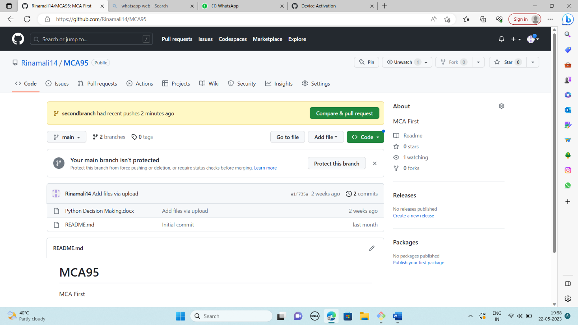

* 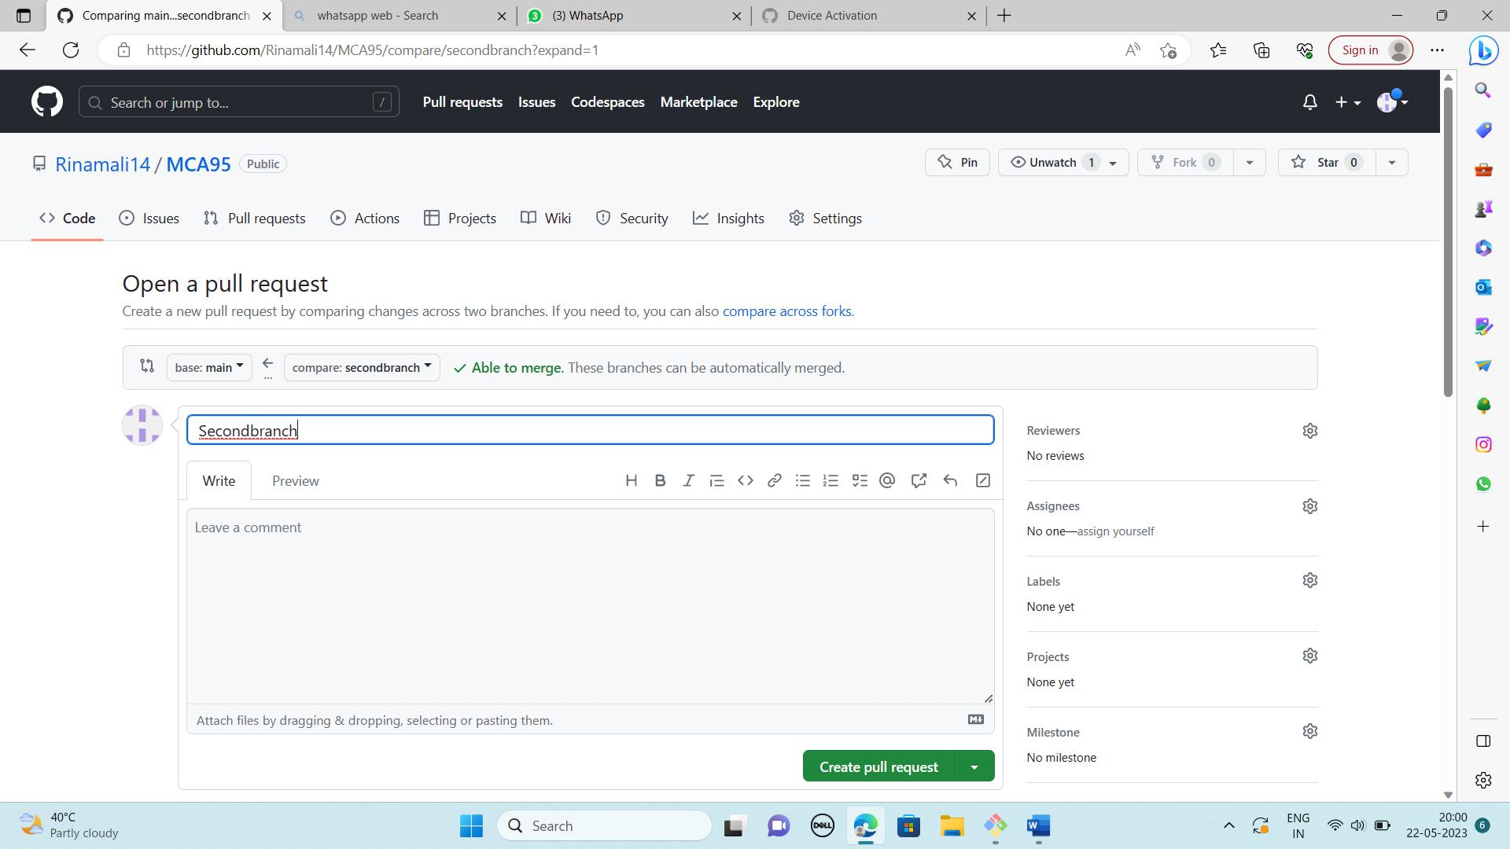**Performing Pull request:**
* 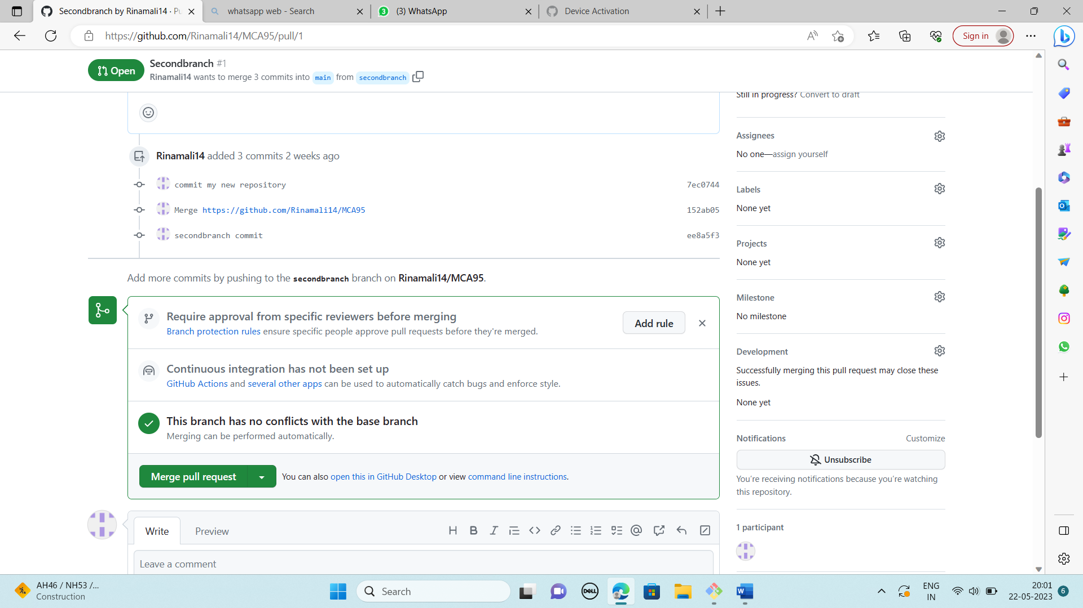**After Pull performing Merge on remote repository at primary branch (master):**
* 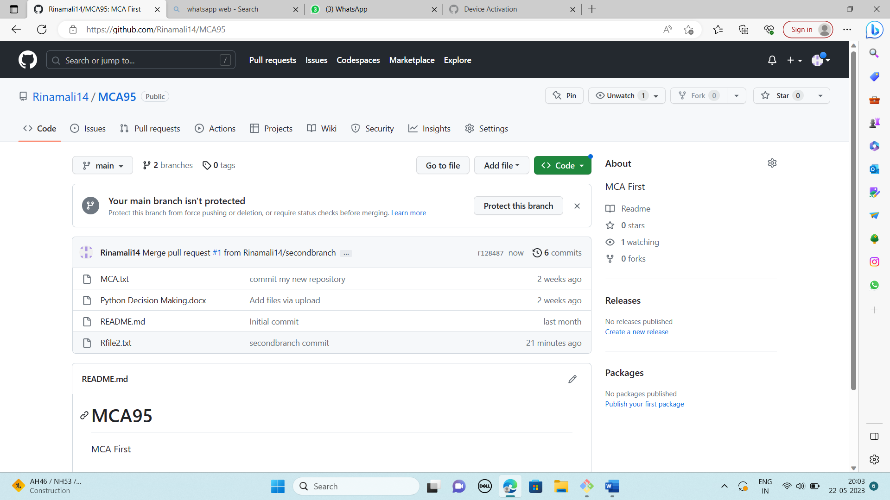**After Merge from branch2 to primary branch (master) on remote repository:**

**Name:Rina Kailas Mali**

**Rollno.:-95**

**Practical Name:- Use git merge to merge you changes to the primary branch**

**Practical no:-8**

Admin@DESKTOP-EAH8S6B MINGW64 ~

$ cd MCA95

Admin@DESKTOP-EAH8S6B MINGW64 ~/MCA95 (secondbranch)

$ git merge master secondbranch

merge: master - not something we can merge

Admin@DESKTOP-EAH8S6B MINGW64 ~/MCA95 (secondbranch)

$ git merge main secondbranch

Already up to date.

Admin@DESKTOP-EAH8S6B MINGW64 ~/MCA95 (secondbranch)

$ git branch --list

main

* secondbranch

Admin@DESKTOP-EAH8S6B MINGW64 ~/MCA95 (secondbranch)

$ git checkout main

Switched to branch 'main'

Your branch is ahead of 'origin/main' by 3 commits.

(use "git push" to publish your local commits)

Admin@DESKTOP-EAH8S6B MINGW64 ~/MCA95 (main)

$ git checkout secondbranch

Switched to branch 'secondbranch'

Your branch is up to date with 'origin/secondbranch'.

Admin@DESKTOP-EAH8S6B MINGW64 ~/MCA95 (secondbranch)

$ git pull

fatal: unable to access 'https://github.com/Rinamali14/MCA95.git/': Could not resolve host: github.com

Admin@DESKTOP-EAH8S6B MINGW64 ~/MCA95 (secondbranch)

$ git pull https://github.com/Rinamali14/MCA95.git

remote: Enumerating objects: 1, done.

remote: Counting objects: 100% (1/1), done.

remote: Total 1 (delta 0), reused 0 (delta 0), pack-reused 0

Unpacking objects: 100% (1/1), 623 bytes | 155.00 KiB/s, done.

From https://github.com/Rinamali14/MCA95

* branch HEAD -> FETCH_HEAD

Updating ee8a5f3..f128487

Fast-forward

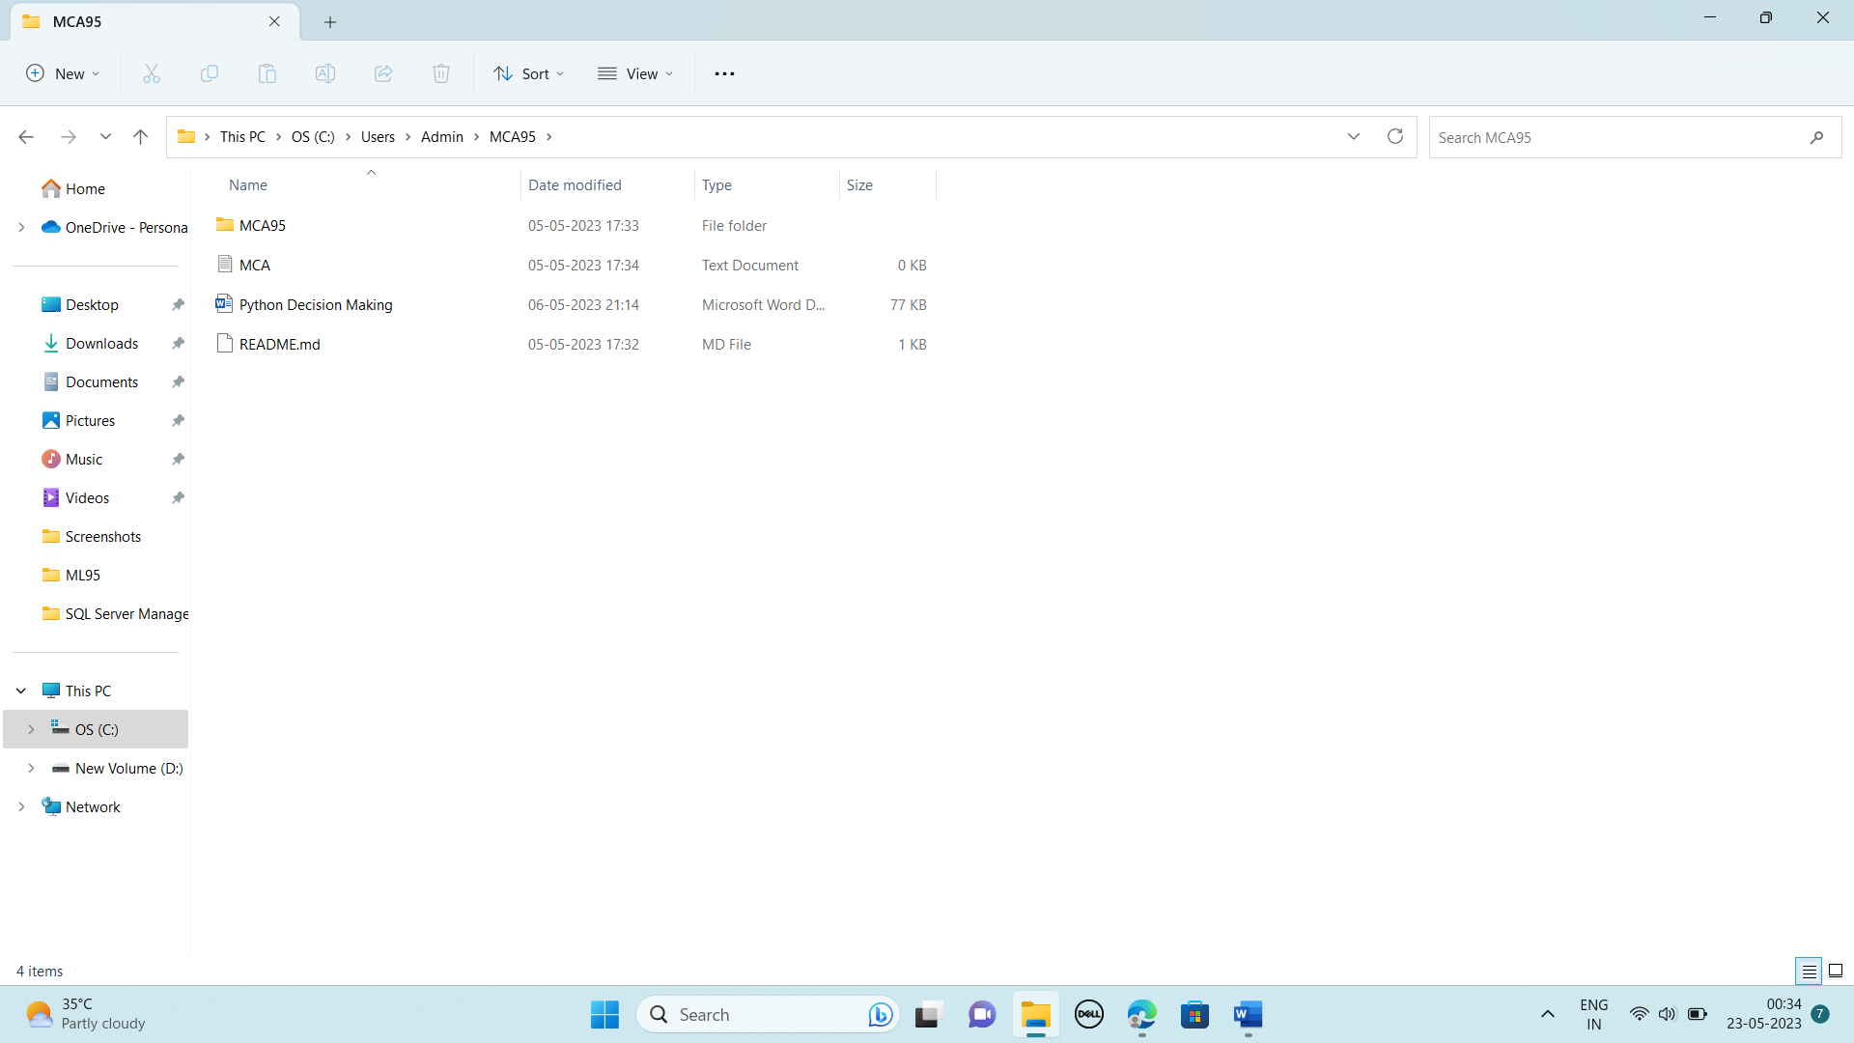

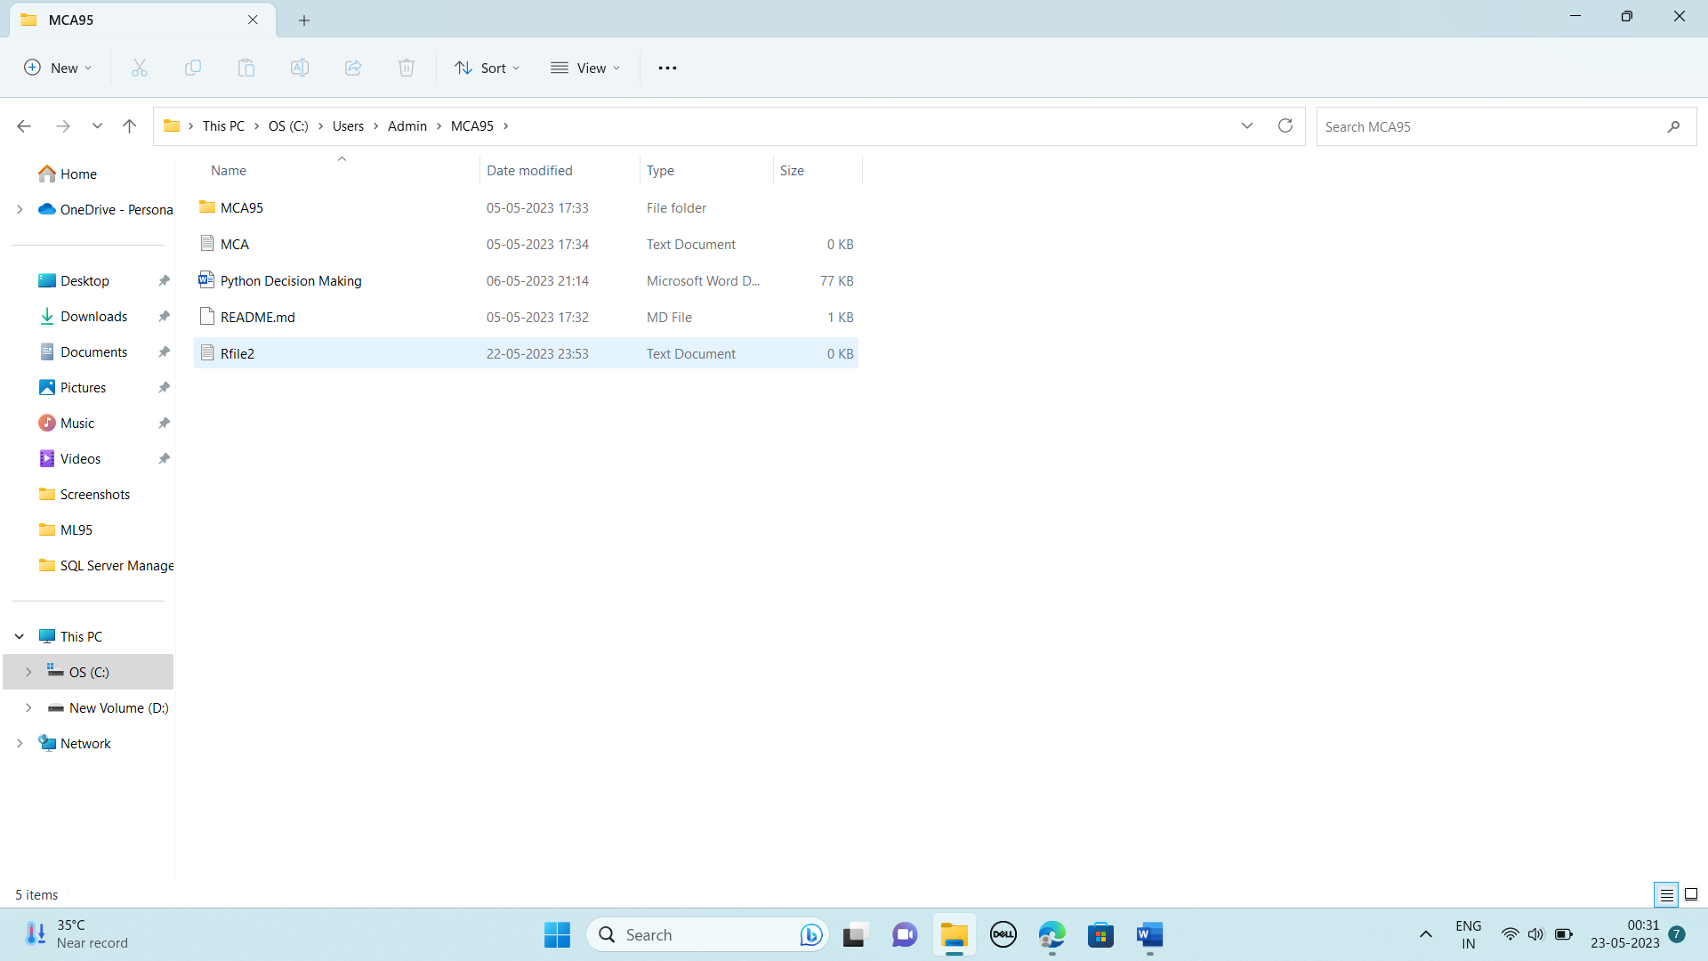

**Name:-Rina Kailas Mali**

**Roll No:-95**

**Practical No:-9**

**Practical Name:- Demonstrate the use of git diff command**

admin@DESKTOP-K3MVO4B MINGW64 ~

$ git clone https://github.com/NileshNarkhede2002/KBCNMU2.git

Cloning into 'KBCNMU2'...

remote: Enumerating objects: 9, done.

remote: Counting objects: 100% (9/9), done.

remote: Compressing objects: 100% (5/5), done.

remote: Total 9 (delta 0), reused 0 (delta 0), pack-reused 0

Receiving objects: 100% (9/9), done.

admin@DESKTOP-K3MVO4B MINGW64 ~

$ cd KBCNMU2

admin@DESKTOP-K3MVO4B MINGW64 ~/KBCNMU2 (main)

$ git diff

**diff --git a/MCA b/MCA**

**index 8646659..17a37dc 100644**

**--- a/MCA**

**+++ b/MCA**

@@ -1 +1,2 @@

this is new file

+this is new file practical no 9

\ No newline at end of file

**diff --git a/MCA2 b/MCA2**

**index 9722bcf..c981179 100644**

**--- a/MCA2**

**+++ b/MCA2**

@@ -1 +1 @@

-this is second file

+MY name Nilesh

admin@DESKTOP-K3MVO4B MINGW64 ~/KBCNMU2 (main)

$ git diff --color-words

**diff --git a/MCA b/MCA**

**index 8646659..17a37dc 100644**

**--- a/MCA**

**+++ b/MCA**

@@ -1 +1,2 @@

this is new file

this is new file practical no 9

**diff --git a/MCA2 b/MCA2**

**index 9722bcf..c981179 100644**

**--- a/MCA2**

**+++ b/MCA2**

@@ -1 +1 @@

this is second fileMY name Nilesh

admin@DESKTOP-K3MVO4B MINGW64 ~/KBCNMU2 (main)

$ git branch branch2

admin@DESKTOP-K3MVO4B MINGW64 ~/KBCNMU2 (main)

$ git checkout branch2

Switched to branch 'branch2'

M MCA

M MCA2

admin@DESKTOP-K3MVO4B MINGW64 ~/KBCNMU2 (branch2)

$ touch branch2.txt

admin@DESKTOP-K3MVO4B MINGW64 ~/KBCNMU2 (branch2)

$ git add branch2.txt

admin@DESKTOP-K3MVO4B MINGW64 ~/KBCNMU2 (branch2)

$ git commit -m "commit branch2 diff"

[branch2 51f998b] commit branch2 diff

1 file changed, 0 insertions(+), 0 deletions(-)

create mode 100644 branch2.txt

admin@DESKTOP-K3MVO4B MINGW64 ~/KBCNMU2 (branch2)

$ git diff main branch2

**diff --git a/branch2.txt b/branch2.txt**

**new file mode 100644**

**index 0000000..e69de29**

admin@DESKTOP-K3MVO4B MINGW64 ~/KBCNMU2 (branch2)

$ git diff main branch2 --name-only

branch2.txt

admin@DESKTOP-K3MVO4B MINGW64 ~/KBCNMU2 (branch2)

$ git diff main

**diff --git a/MCA b/MCA**

**index 8646659..17a37dc 100644**

**--- a/MCA**

**+++ b/MCA**

@@ -1 +1,2 @@

this is new file

+this is new file practical no 9

\ No newline at end of file

**diff --git a/MCA2 b/MCA2**

**index 9722bcf..c981179 100644**

**--- a/MCA2**

**+++ b/MCA2**

@@ -1 +1 @@

-this is second file

+MY name Nilesh

**diff --git a/branch2.txt b/branch2.txt**

**new file mode 100644**

**index 0000000..e69de29**

admin@DESKTOP-K3MVO4B MINGW64 ~/KBCNMU2 (branch2)

$ git diff main...branch2

**diff --git a/branch2.txt b/branch2.txt**

**new file mode 100644**

**index 0000000..e69de29**

